A WEB BASED PERSONAL FINANCE MANAGEMENT APPLICATION RESEARCH PROPOSAL.

BY

OTIM WILLIAM GERISON

S19B23/421

A87886

Email Addresses: [otim22gerison@gmail.com](mailto:otim22gerison@gmail.com)

Phone Number: +256 775 945-681

**TECHNOLOGIES EMPLOYED.**

For this project, the researcher intends to develop the web application using Spring Boot, a Java enabled Framework in conjunction with technologies like React for the frontend and Java, MySQL from the backend side.

In regards to Spring boot, it is based on a M-V-C (Model View Controller) which is a software design pattern for developing web applications using the framework.

The model contains the core data of the application and it consists of Plain Old Java Object commonly abbreviated as POJO.

The View is the one responsible for rendering the model’s data and it also generates HTML output that can be interpreted by the user’s browser.

The Controller is that part which contains the business logic of the application.

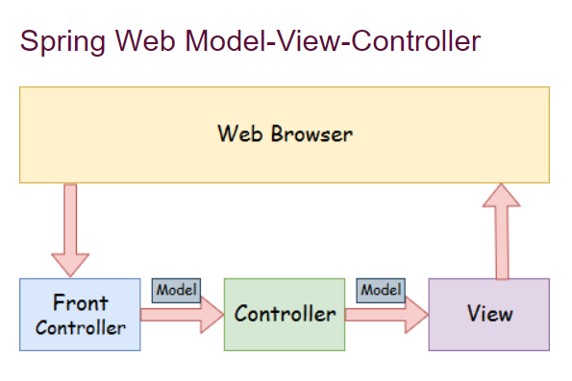

Figure 1: Visual Representation of SpringMVC

The web application will be built in the eclipse Integrated Development Environment.

**PROJECT OVERVIEW**

Personal finance management systems play an important role in managing finance at the personal level and of everyday use. They are intended to help the user of the application manage their finances. This can be done by inputting income sources and noting down expenditures. This then gives the user the option of generating reports inform of charts to see their income and expenditure rates and enable them make decisions such as increasing income streams to match expenditure or reducing expenditures to match incomes. This in turn prevents them from running in debts or over spending and also helps them proportion their funds in regards to priority expenditures.

The project is due to have a login page for returning users and a signup page for new users. Upon accessing the system, the user can add multiple streams of incomes to see how much income they are receiving. In addition to this they can add their expenditures to see where their income is going.

There is also an admin interface however, this is for the system that is responsible for over seeing the system and ensuring it is functioning smoothly and as required.

**USE CASE DIAGRAM**

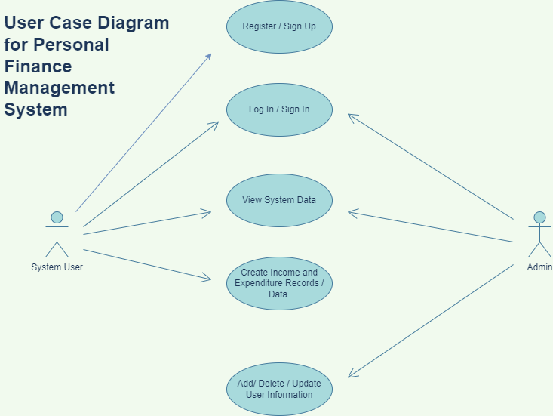

Figure 2: Use Case Diagram

**ACTIVITY DIAGRAM**

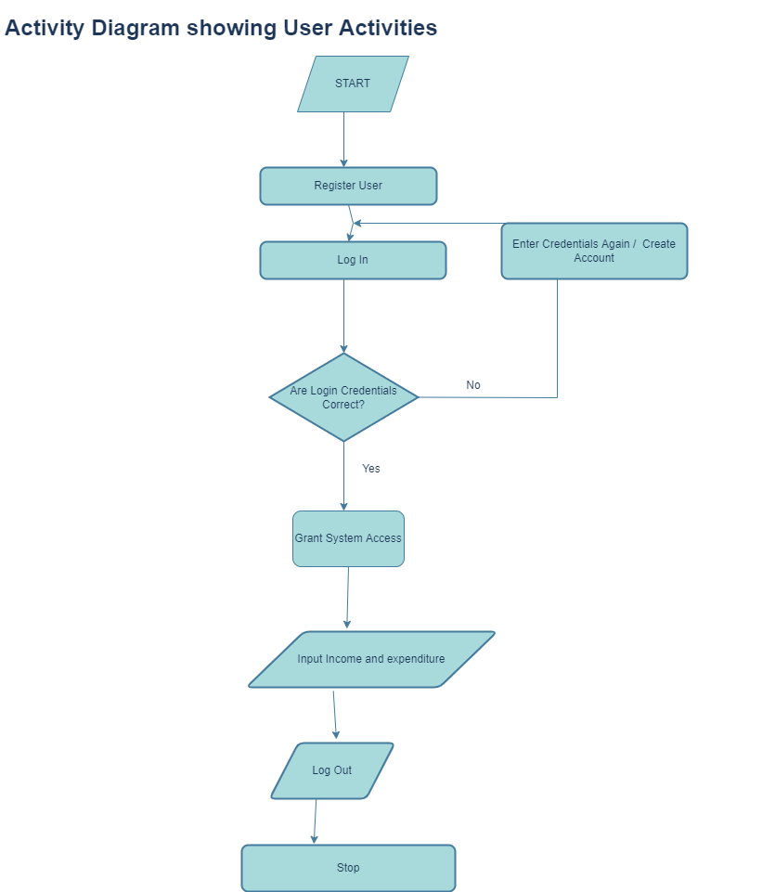

Figure 3: User Activity Diagram

**CLASS DIAGRAM**

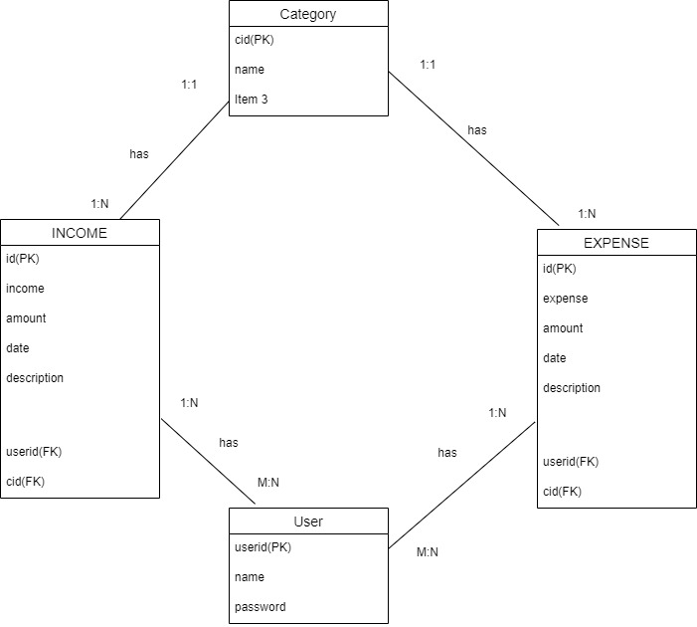

Figure : Class Diagram

**CONCLUSION**

People always want to find the way to make their life easy and comfortable. Currently, we depend on the web pages much for everything as there are many web applications depending upon various requirements. The financial management system to be developed will be a very effective information system and thus benefited both the system developer and its users. The proposed system application also demonstrated proper security requirements with the financial activities and personal information.

**TABLE OF FIGURES**

Figure 1: Visual Representation of SpringMVC 2

Figure 2: Use Case Diagram 4

Figure 3: User Activity Diagram 5

Figure 4: Class Diagram 6